DAY 3 ASSIGNMENT :

SOLUTIONS:

1) create table student (STU_ID number(4) primary key,STU_NAME varchar2(30) not null,SEX character(6) not null,Tot_MARKS number(6,2) not null);

insert all

into student (STU_ID,STU_NAME,SEX,Tot_MARKS) values(10,'Anu','Female',553)

into student (STU_ID,STU_NAME,SEX,Tot_MARKS) values(20,'Anbu','Male',345)

into student (STU_ID,STU_NAME,SEX,Tot_MARKS) values(30,'Malini','Female',567)

into student (STU_ID,STU_NAME,SEX,Tot_MARKS) values(40,'Sankar','Male',590)

into student (STU_ID,STU_NAME,SEX,Tot_MARKS) values(50,'Varshan','Male',587)

select * from dual;

1. select max(ToT_MARks) from student;

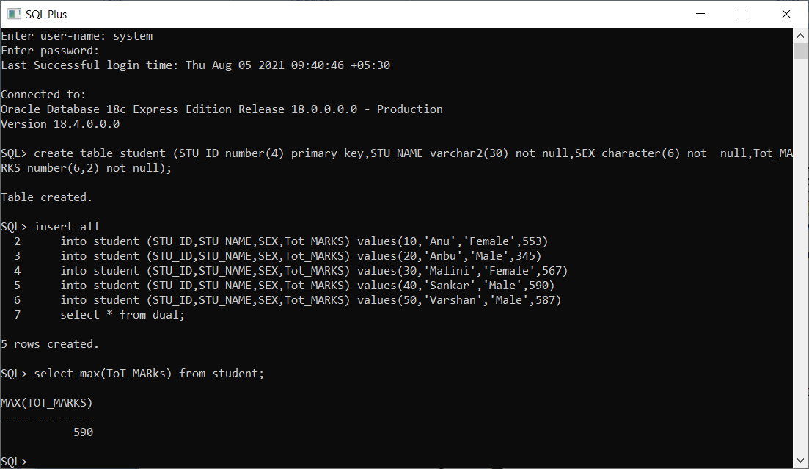

1. select sex,count(*) from student group by sex;

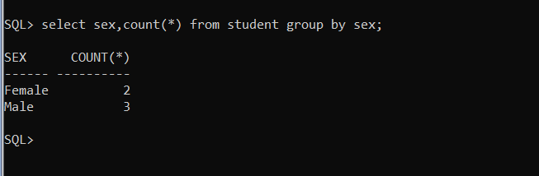

c) select sex,avg(TOT_Marks) from student group by sex;

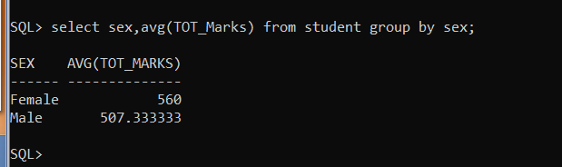

d) select * from student where Tot_Marks > (select avg(Tot_Marks) from student);

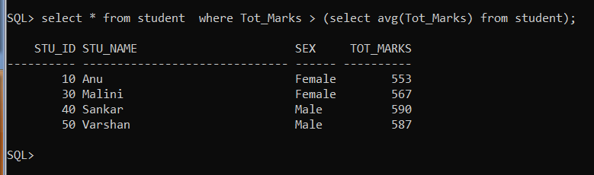

2) a) select * from student where length(stu_name)=3;

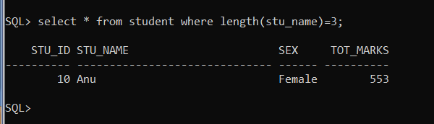

b)select * from student order by sex asc,tot_marks desc;

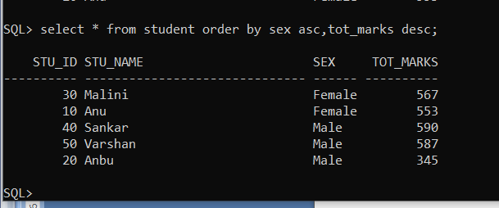

3) select max(tot_marks) as max_marks,min(tot_marks) as min_marks,max(tot_marks)-min(tot_marks) as diff from student;

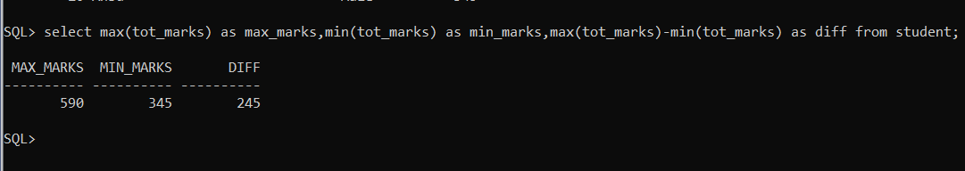

4) create view mytable as select * from student where tot_marks>200 WITH CHECK OPTION;

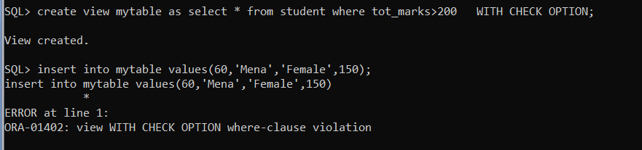

5) insert all

into student (STU_ID,STU_NAME,SEX,Tot_MARKS) values(60,'Alla','Female',552)

into student (STU_ID,STU_NAME,SEX,Tot_MARKS) values(70,'Farah','Male',340)

into student (STU_ID,STU_NAME,SEX,Tot_MARKS) values(80,'Madana','Female',560)

select * from dual;

savepoint s1;

delete from student where Stu_id=80 ;

delete from student where Stu_id=70 ;

rollback to s1;

select * from student;

commit;

rollback to s1;

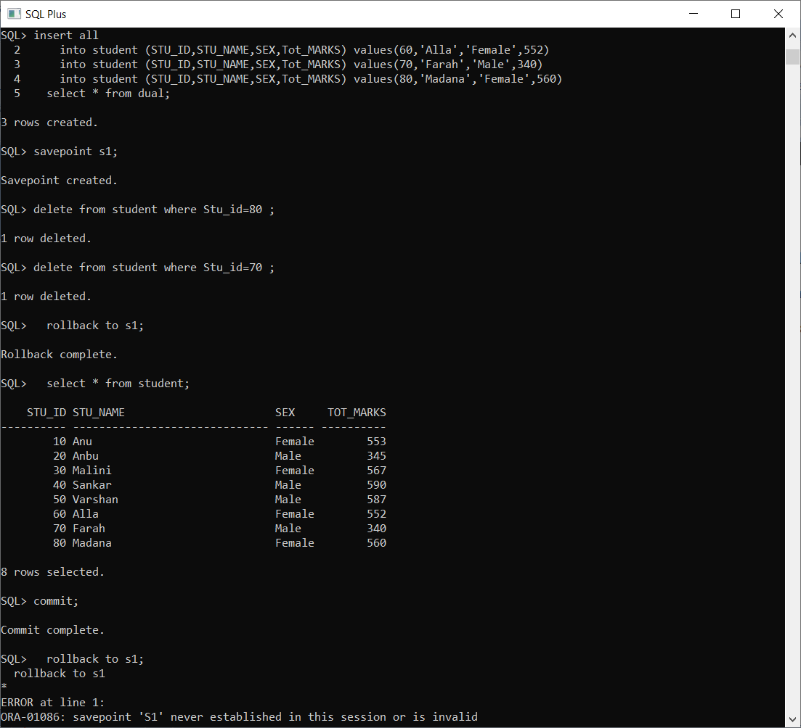

6) DECLARE

a NUMBER:= 5;

b NUMBER:=6;

BEGIN

CASE a

when 5 then dbms_output.put_line(' Square of (5): ' || a*a);

END CASE;

CASE b

when 6 then dbms_output.put_line(' cube of (6): ' || b*b*b);

END CASE;

END;

/

